Creating or editing a page.

Page 2, Understanding the interface.

Page 5, Editing a page.

Page 8, Adding and managing blocks.

Page 10, Adding columns.

Page 12, Adding elements.

Page 14, Using keyboard shortcuts.

Understanding the interface
Before you start to create a page or edit a page, it would be better to learn the interface of the editor first. Here is the screenshot of the editor.
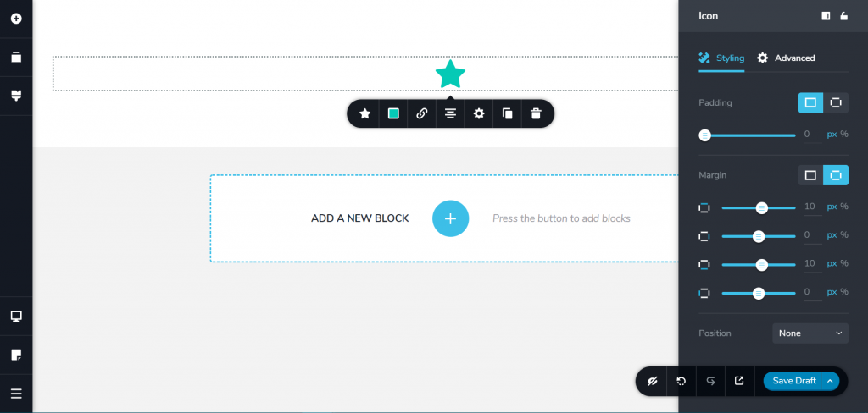

As you can see in the screenshot above, the interface of the editor looks easy to use. The initial interface consists of only the left panel and the canvas area. The panel on the right side (the settings panel), will only appear when you click the gear icon on the settings bar when you want to customise a certain element.
Here are the elements of the editor:
The left panel
What we see here is the fixed panel which lies on the left side of the editor (as you can see in the screenshot above). You can use this panel to add design elements (text, image, shape, form, button, and so on), reorder the blocks, set the page layout, and switch to device mode (desktop, tablet, smartphone).

Canvas area
The word refers to your actual work area where you add your design elements.
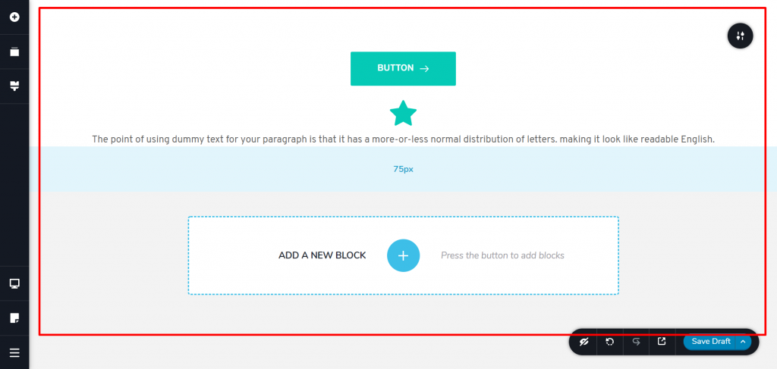

Settings bar
In some ways, the user experience of the editor is pretty similar to the default block editor of WordPress. When you click a certain element on the canvas area, a bar that consists of rows of setting options will appear. You can use this bar to customize the associated element. The setting options are varied, depending on the element you click.

Settings panel
On the settings bar of every element, you will see a gear icon. Clicking this icon will open a new panel on the right side. It’s called the settings panel. This panel allows you to make advanced settings to the associated element.

Editing a page
After learning the interface of the editor, you can start working with it. To edit a page, first, create a new page (Pages -> Add New). Give your page a name just like usual and click the Edit button to edit the page with the editor. Clicking the button will take you to the editor.

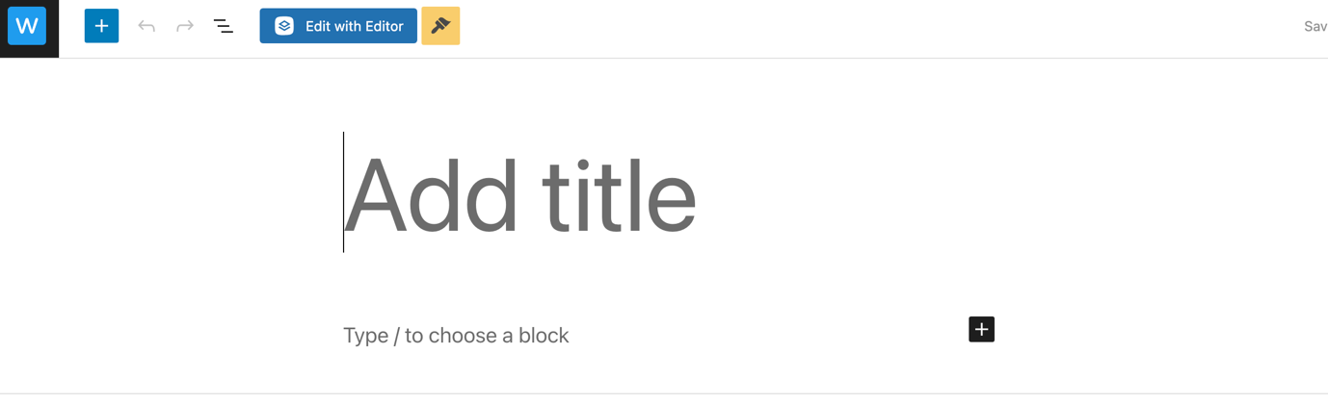

Before adding any element to your page, you can set the layout page first (called template). To do so, click the paper icon on the lower side of the left panel and select the layout you want to use.
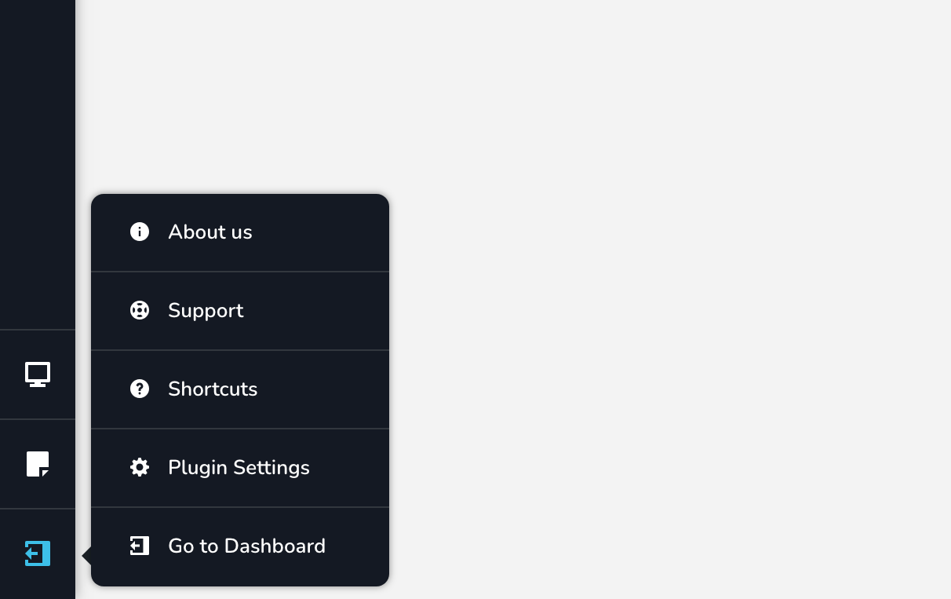

The layout options available depend on the theme you use. After setting the page layout, you can start adding elements to your page. Start by adding a new block.
You can click the plus button on the canvas area to add a new block. You can then add the elements from the left panel. To add an element, you can drag the element you want to add and drop it to a block on the canvas area.

Once done editing your page, you can publish it by clicking the tiny arrow icon on the bottom-right corner and selecting Publish Page.

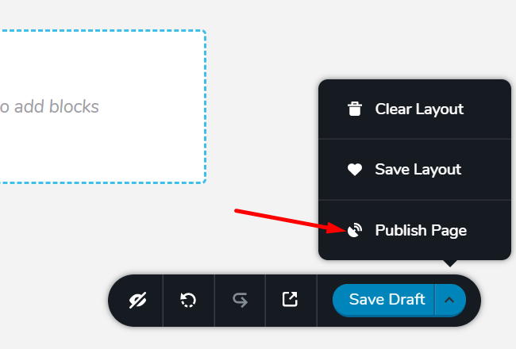

You can also preview your page first before making it live. To do so, you can click another arrow icon on the bottom area. You need to save the page as a draft first by clicking the Save Draft button before previewing your page.

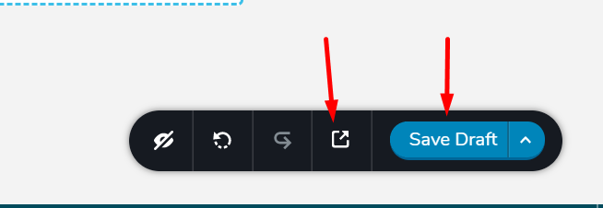

Once you are done working with the editor and want to switch back to the WordPress dashboard, you can click the hamburger icon on the bottom-left corner and select Go to Dashboard.

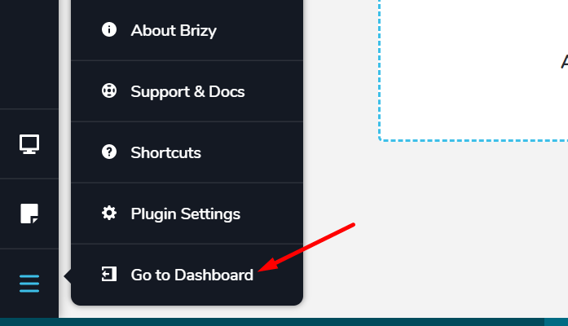

Adding and managing blocks
Two terms you need to familiarize yourself with when working with the editor: block and element.
A block is a container where you can place design elements while an element is the actual design element you can use to create your page.
As mentioned above, to add a new block, you can simply click the plus button on the canvas area. To customize a block (such as setting the background colour, margin, layout, and so on), you can click the icon like a mixer. You can see this icon when hovering your mouse over a block. Clicking the mixer icon will open the settings bar where you can customize the block.

To delete a block, you can simply click the trash icon on the settings bar. You can also reorder the blocks. To do so, you can click the block icon on the left panel. Drag a block downward or upward to reorder it. You can also delete a block from here.

A block can be saved to the library in case you want to reuse it later on other pages. To save a block to the library, hover your mouse over the block you want to save, open the settings bar, and click the heart icon.

To access the saved blocks or layouts, you can go to the Saved tab when adding a new block.

Adding columns
On the editor, the column is not a required element, but adding columns to a block would make your design organised. You can use a column as a smaller container to place design elements. To add a column to a block, you can simply drag the Column element from the left panel and drop it to the canvas area.

The Column element will add two columns to your block. To insert a new column, hover your mouse over an existing column and click the arrow icon on the top-right corner on the column. Click the plus icon on the appearing bar to add a new column. To delete a column, you can simply click the trash can icon on the bar.

To resize a column, hover your mouse over the column you want to resize. Click and hold the column handle while dragging it leftward or rightward.

To add a background to a column you can open the settings bar by clicking the arrow icon on the column you want to add the background to. You can use an image as the background or a solid colour as the background. If you want to set the border colour or set the box shadow, you can do so from the Border tab and Shadow tab on the colour picker.

You can click the gear icon on the settings bar to open the settings panel in case you want to make the advanced settings to the column.

Adding elements
Elements are the actual design elements you can use to make your page.
The editor offers over 30 elements in total. To add one, you can simply drag the element you want to add from the left panel and drop it to the canvas area.

To customise the element, you can click the associated element to open the settings bar. Please note that the customisation options available on the settings bar are varied, depending on the element. To make the advanced settings such as padding, margin, entrance animation, and so on, you can click the gear icon on the settings bar to open the settings panel.

If you want to edit the default text content of the element that contains text content, you can simply block (or delete) the default text and replace it with your own text.

To delete an element, you can click the trash can icon on the settings bar or simply press the Delete key on the keyboard.

Using keyboard shortcuts
To streamline your workflow, the editor offers keyboard shortcuts you can make use of. You can see the list of keyboard shortcuts by clicking the hamburger icon on the bottom-left corner and selecting Shortcuts. Here are the keyboard shortcuts.
Ctrl + C | Copy
Ctrl + V | Paste
Ctrl + Shift + V | Paste style
Ctrl + D | Duplicate
Delete | Delete
Ctrl + Left/right arrows | Horizontal align
Ctrl + Up/down arrows | Vertical align
Ctrl + Z | Undo last operation
Ctrl + Shift + Z | Redo
Ctrl + S | Save draft/Update page
Ctrl + +/- | Responsive zoom in/zoom out
Ctrl + Shift + A | Add a new block
Esc | Select the parent element

